Summary of the project 2.2:
From the data mining and the Collective Intelligence;
Bayesian classifiers base on calculating the conditional probability of:
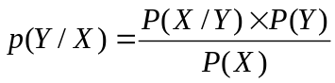
It known as posterior probability, where, P(X) is prior probability. From the training data, we need to learn the P(Y/X) for every combination of X and Y.
- If the posterior probability of P(Yes/X) is greater than P(No/X) then the records is classified as Yes.
- The Bayesian classifies are useful because allow us to express posterior probability in term of prior probability P(Y) ,the class – conditional probability P(X/Y) and the evidence ,P(X).
- Where P(X) is constant, P(Y) can be easy to estimate from the training set by computing the fraction of training records that belong to each class.
- To estimate P(X/Y) we use some Bayesian classification methods:
- I will use in my computing classifiers the cross validation equal to 10 and 11
Because they give me the best result with smaller classification errors after I tried many values of cross validation.
- using AODE method:
The result depend on the cross validation.
- if it is (10):
Correctly Classified Instances 7 50 %
Incorrectly Classified Instances 7 50 %, see file result File (1).
- if the cross validation is 11 then I obtained the best results ,which is
Correctly Classified Instances 8 57.1429 %
Incorrectly Classified Instances 6 42.8571 %
Figure (1). Describes the error where the X axis is the Term. And the Y axis is
The Hum.
- using BayesNet:
it gives better results than AODE when the cross validation is (10):
Correctly Classified Instances 8 57.1429 %
Incorrectly Classified Instances 6 42.8571 %
- when the cross validation is (11), which gave the best result for AODE, is gives the best results in BayesNet too and it is better than AODE :
Correctly Classified Instances 10 71.4286 %
Incorrectly Classified Instances 4 28.5714 %
See figure (2), for the tree and figure (3), for the visualize the margin curve
- using NaiveBayes:
for the cross validation is (10) it gives the same results as BayesNet:
Correctly Classified Instances 8 57.1429 %
Incorrectly Classified Instances 6 42.8571 %
And the same in case if cross validation is (11):
Correctly Classified Instances 10 71.4286 %
Incorrectly Classified Instances 4 28.5714 % , see file results, file (2).
Figure (4), for the visualize the margin curve and figure (5) for the error.
- ANN:
- here classifiers attempts to simulate biological neural systems:
- using MultilayerPerceptron classifier :
it gives great results when the cross validation is (100):
Correctly Classified Instances 10 71.4286 %
Incorrectly Classified Instances 4 28.5714 %, see file (3).
With less classifier error see figure (6).
However, when the cross validation is (11), which gave the best results in last
Steps, here gives the opposite.
Correctly Classified Instances 8 57.1429 %
Incorrectly Classified Instances 6 42.8571 %
- using the VotedPerceptron:
- When the cross validation is (10):
The results are:
Correctly Classified Instances 8 57.1429 %
Incorrectly Classified Instances 6 42.8571 %, see file (4) and figure (7) for the classification error.
- when the cross validation is (11) it gives:
Correctly Classified Instances 9 64.2857 %
Incorrectly Classified Instances 5 35.7143 %
- using Winnow classifier :
- when the cross validation is (10) ,it gives interesting results :
Correctly Classified Instances 7 50 %
Incorrectly Classified Instances 7 50 % ,see file (5), and
Figure (8) of the classification error and figure (9) of the visualize the margin
curve.
- when the cross validation is (11) the results are:
Correctly Classified Instances 8 57.1429 %
Incorrectly Classified Instances 6 42.8571 %, see file (6) and
Figure (10) of the classification error, figure (11) of the visualize the margin.

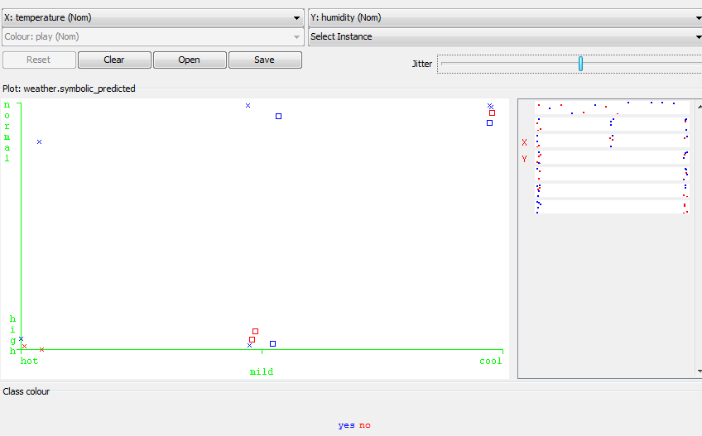
Figure (1).

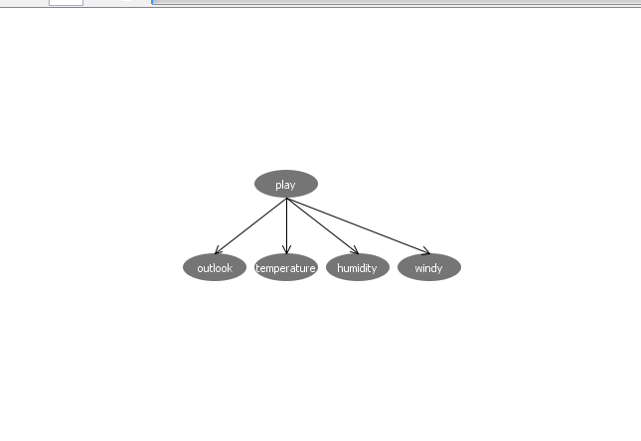
Figure (2).
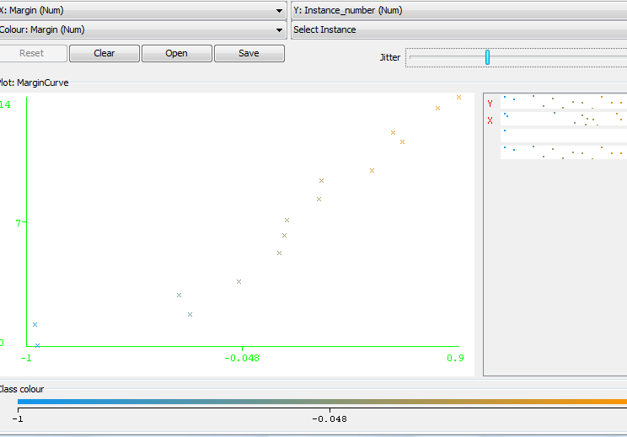
Figure (3).
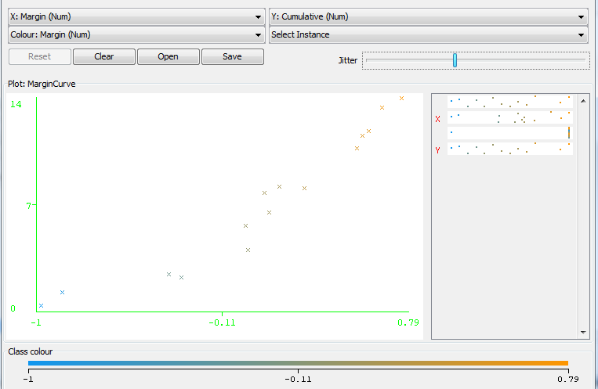
Figure (4).
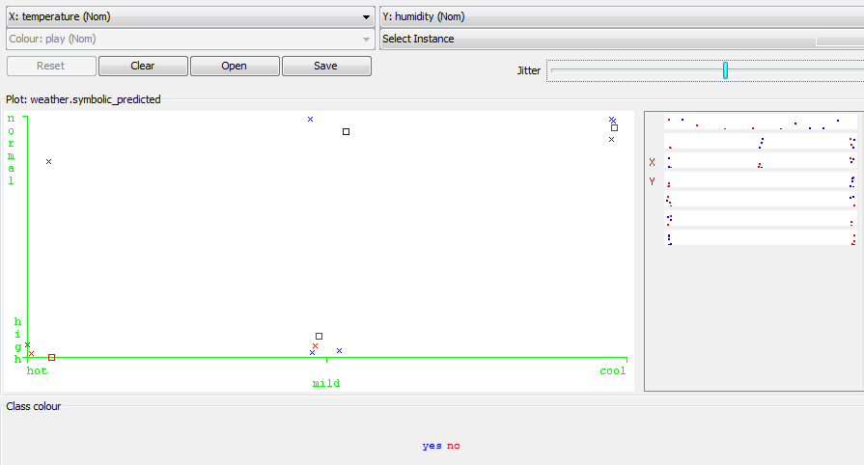
Figure (5).
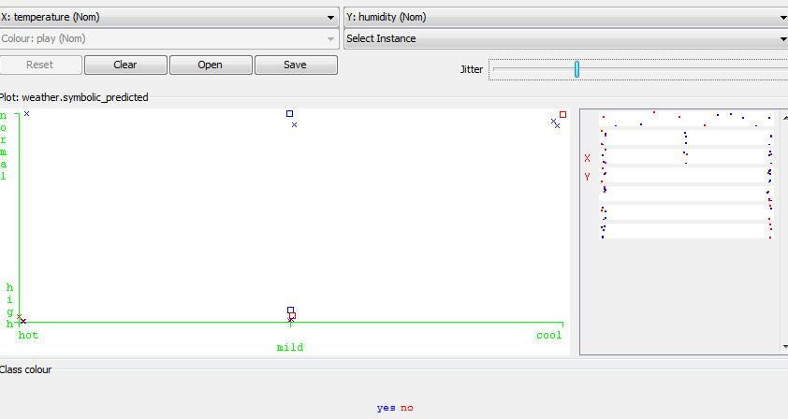
Figure (6).
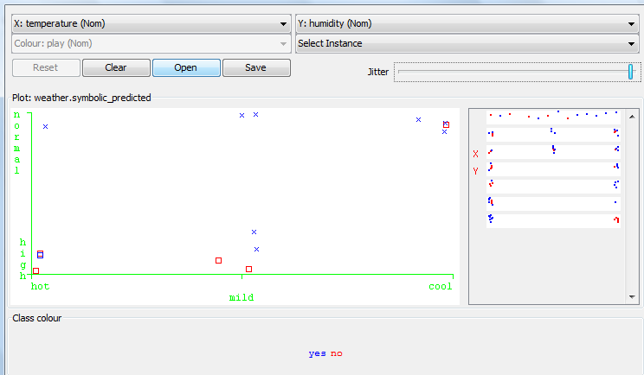
Figure (7).
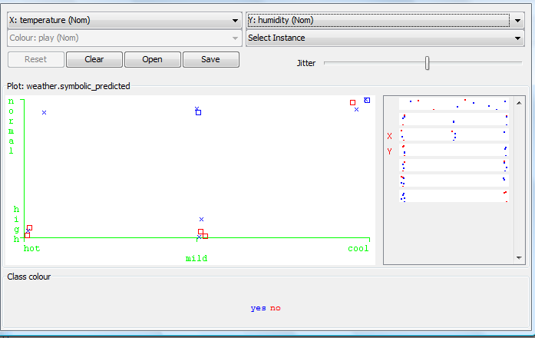

Figure (8).
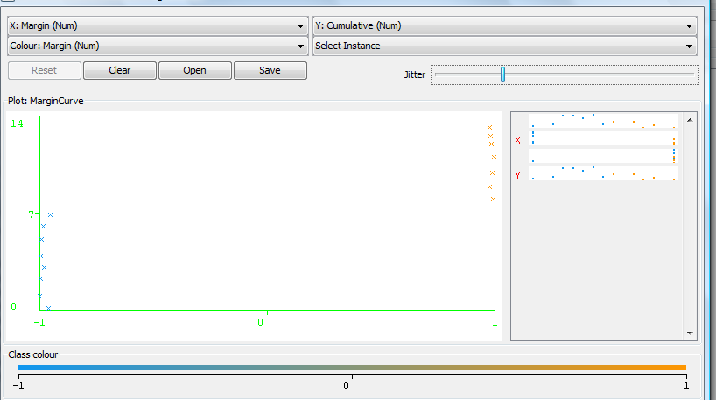
Figure (9).
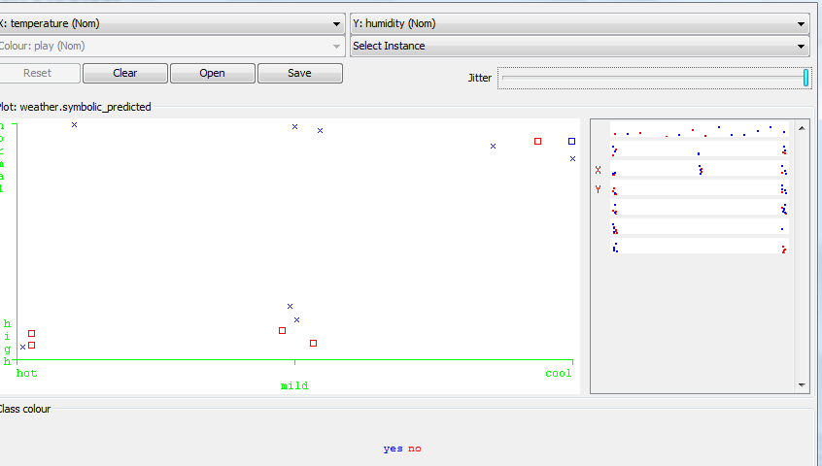
Figure (10).
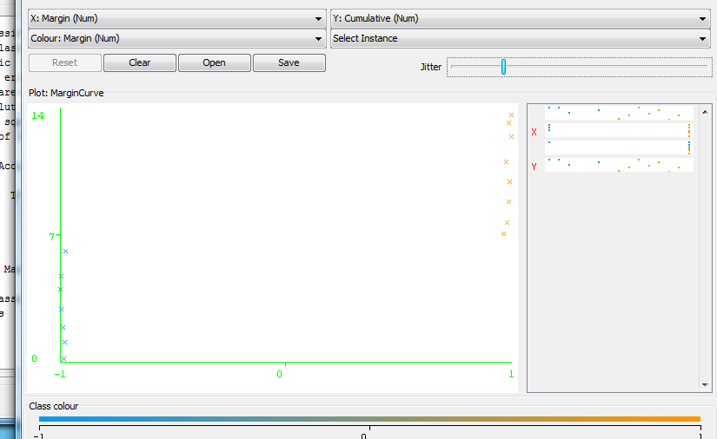
Figure (11).

